Model outputs Colab

* Vælg model ud fra val loss
  + Jesper on Accuracy vs. Loss: “[...]always choose based on loss. Go back to the slides about the loss function and recall what it does: it heavily penalizes wrong predictions. Accuracy doesn't do that. In fact, accuracy as a performance measure is easy to trick when you are working with an unbalanced classification problem -> just assign more predictions to the majority category (categories) and accuracy may get a boost.”
* The small convnet



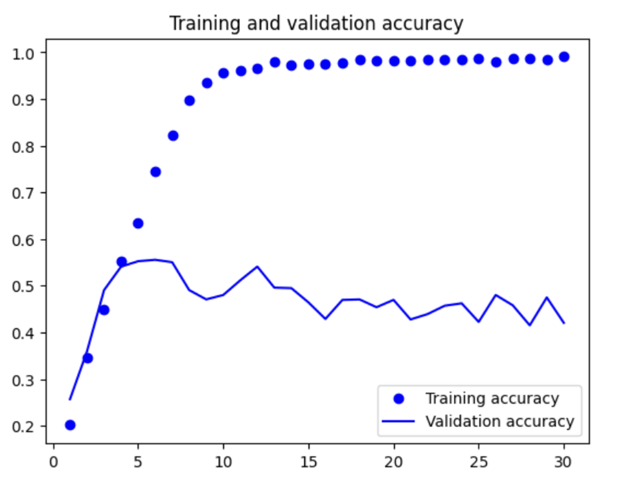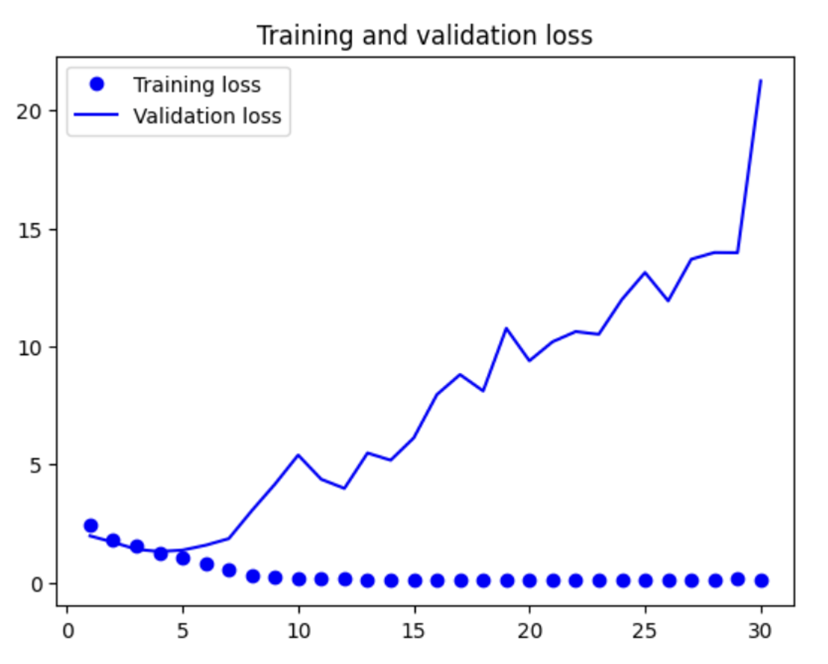

* + Add more Conv2D and MaxPooling2D stages??
* The convnet with data augmentation



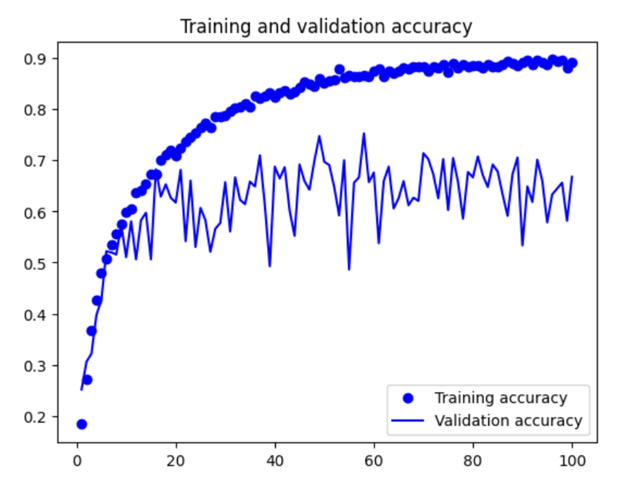 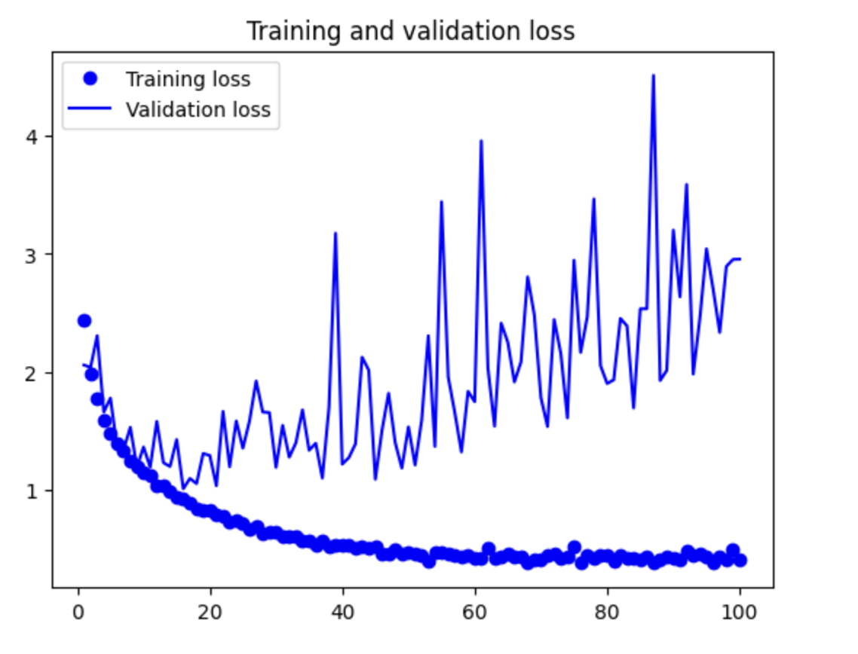

* + By further tuning the model’s configuration (such as the number of filters per convolution layer, or the number of layers in the model), we might be able to get an even better accuracy, likely up to 90%.
* The convnet with residual connections
  + Giving issues
* The convnet with batch normalization

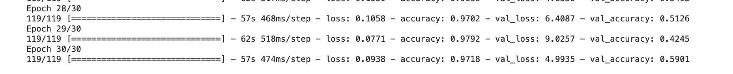

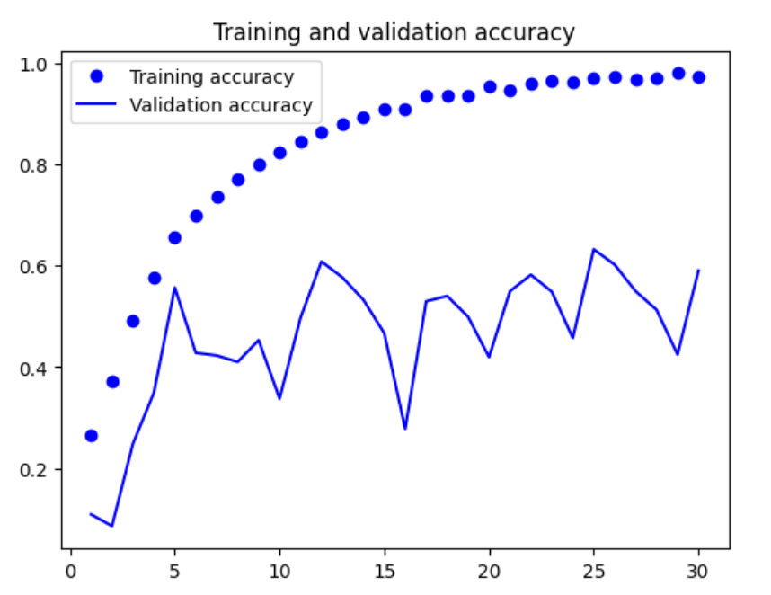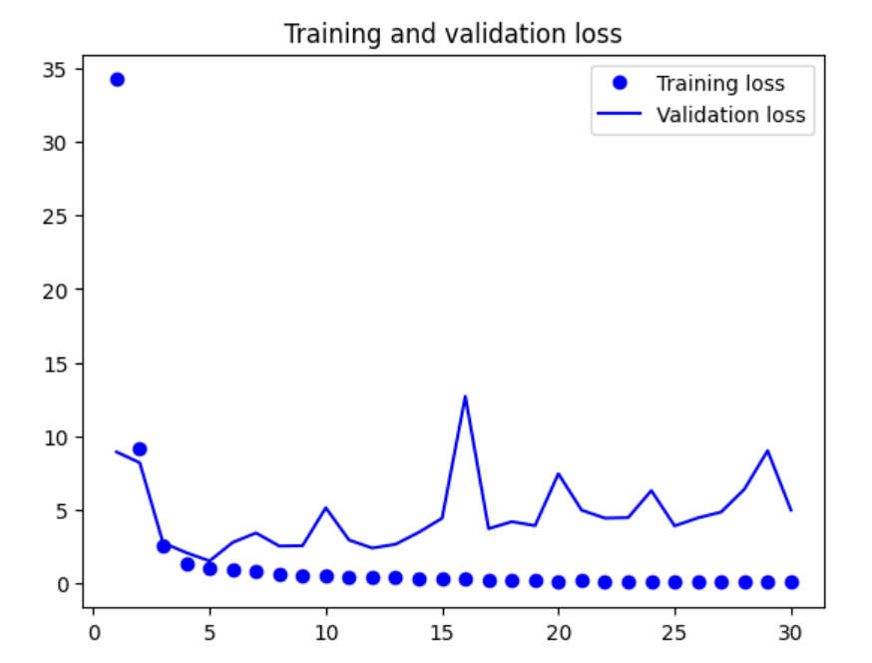

* The convnet with depthwise separable convolutions

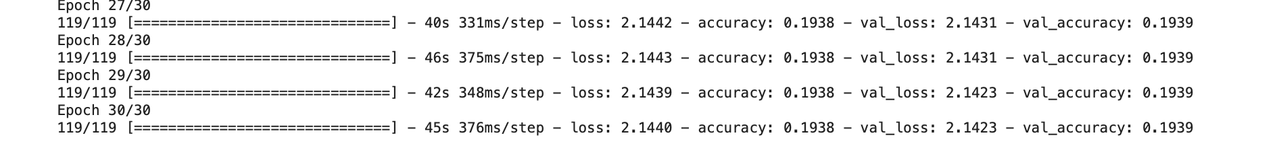

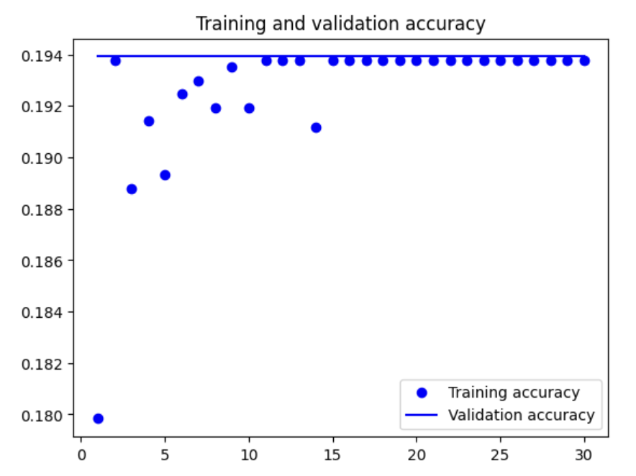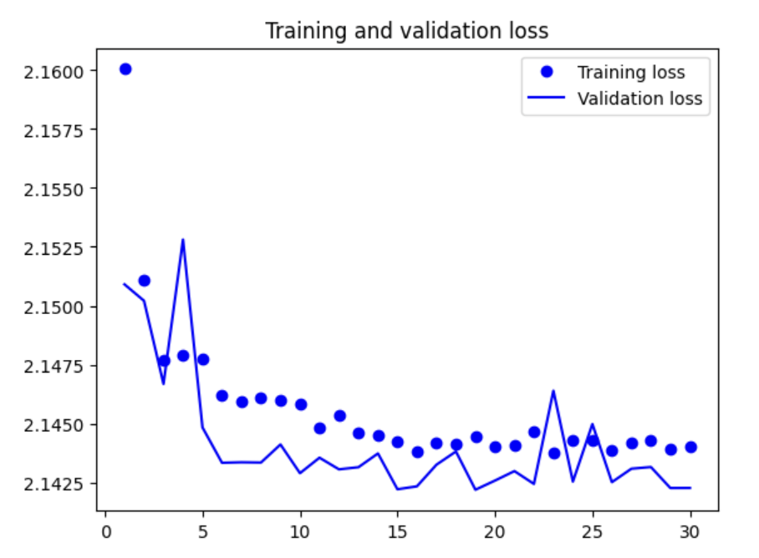

* The mini Xception-like model

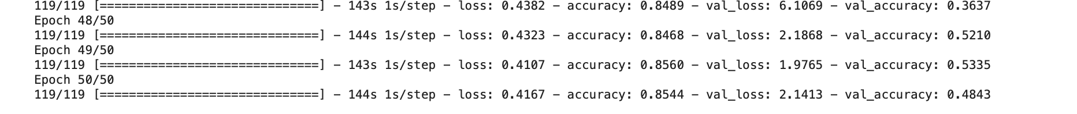

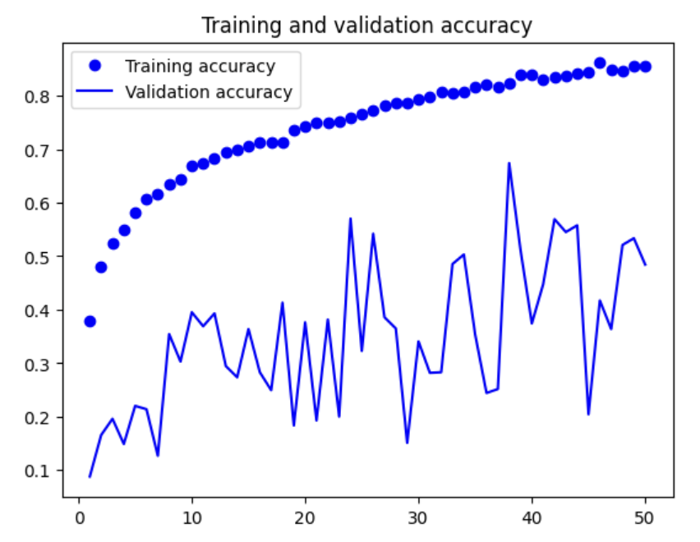 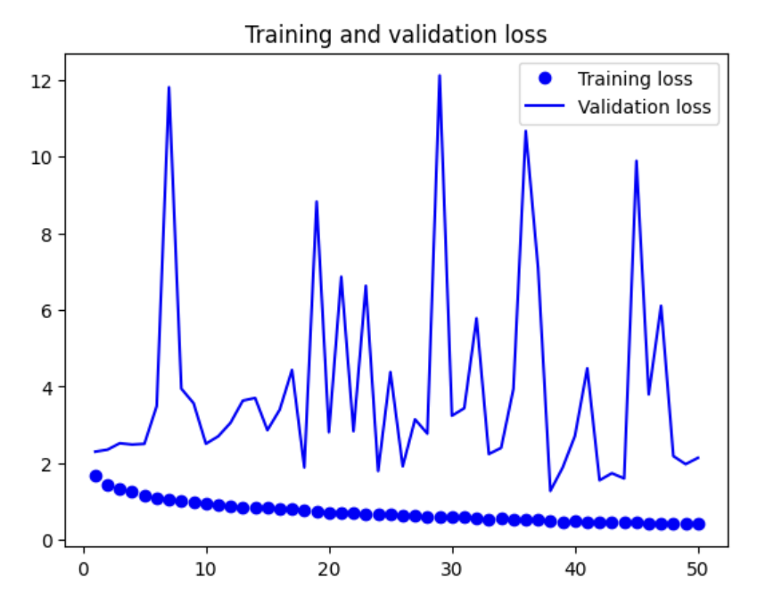

* Building a model from scratch 1
* # defining the data augmentation stage
* # loading libraries
* from tensorflow import keras
* from keras import layers
* # defining the data augmentation stage
* data_augmentation = keras.Sequential( # defining the data augmentation
* [
* layers.RandomFlip("horizontal"), # adding random horizontal flip (this will flip the image horizontally with a 50% probability)
* layers.RandomRotation(0.1), # adding random rotation (this will rotate the image by a random angle between -0.1 and 0.1 radians)
* layers.RandomZoom(0.2), # adding random zoom (this will zoom the image by a factor between 0.8 and 1.2)
* ]
* )
* from tensorflow import keras
* from tensorflow.keras import layers
* inputs = keras.Input(shape=(524, 524, 3)) # specifying the input shape of the model as 524x524
* x = data_augmentation(inputs) # adding the data augmentation layer
* x = layers.Rescaling(1./255)(x) # rescaling the input data to be between 0 and 1
* x = layers.Conv2D(filters=32, kernel_size=5, use_bias=False)(x) # adding a convolutional layer with 32 filters of size 5x5 and no bias
* for size in [32, 64, 128, 256, 512]: # looping through the sizes
* residual = x # saving the input in a variable called residual
* x = layers.BatchNormalization()(x) # adding a batch normalization layer
* x = layers.Activation("relu")(x) # adding a relu activation layer
* x = layers.Conv2D(size, 3, padding="same", use_bias=False)(x) # adding a convolutional layer with the specified number of filters, a filter size of 3x3, same padding and no bias
* x = layers.BatchNormalization()(x) # adding a batch normalization layer
* x = layers.Activation("relu")(x) # adding a relu activation layer
* x = layers.Conv2D(size, 3, padding="same", use_bias=False)(x) # adding another convolutional layer with the specified number of filters, a filter size of 3x3, same padding and no bias
* x = layers.MaxPooling2D(3, strides=2, padding="same")(x) # adding a max pooling layer with a pool size of 3x3, a stride of 2 and same padding
* residual = layers.Conv2D( # adding a convolutional layer to the residual variable
* size, 1, strides=2, padding="same", use_bias=False)(residual) # with the specified number of filters, a filter size of 1x1, a stride of 2, same padding and no bias
* x = layers.add([x, residual]) # adding the output of the max pooling layer and the residual variable
* x = layers.GlobalAveragePooling2D()(x) # adding a global average pooling layer
* x = layers.Dropout(0.5)(x) # adding a dropout layer with a rate of 0.5
* outputs = layers.Dense(9, activation="softmax")(x) # adding a dense layer with 9 units (one for each class) and softmax activation function
* model = keras.Model(inputs=inputs, outputs=outputs) # creating a model with the specified inputs and outputs

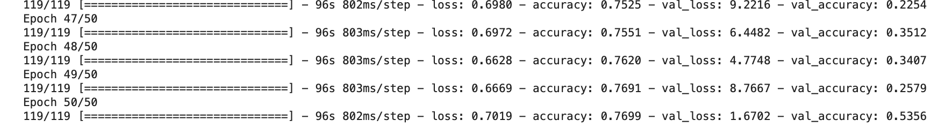

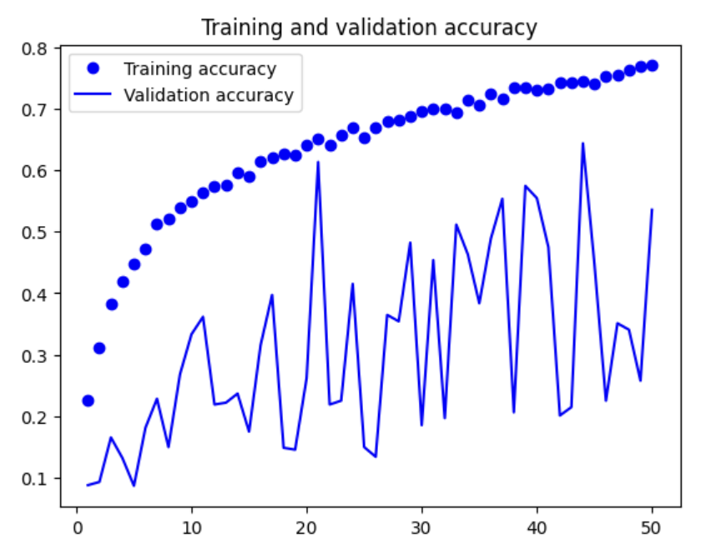 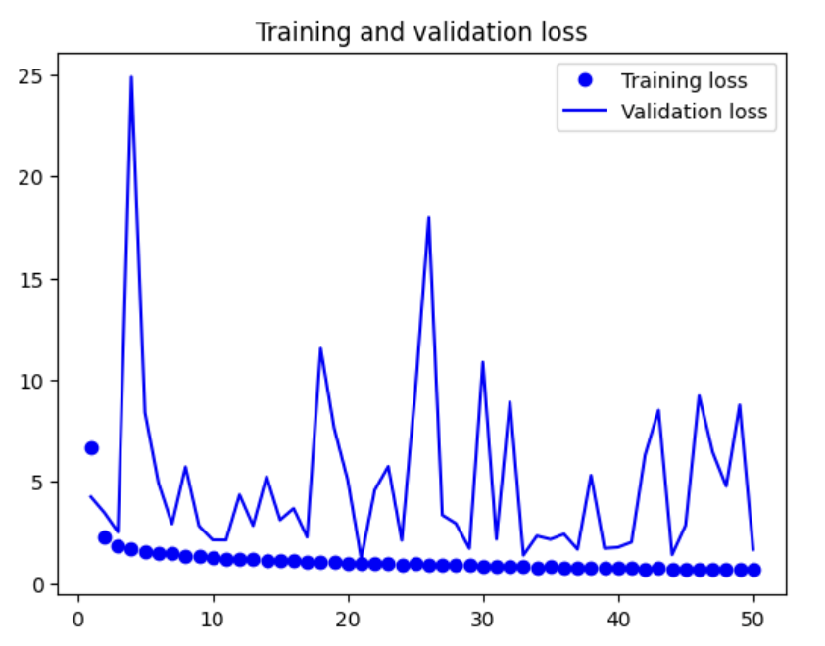

* Building a model from scratch 2
* # defining the data augmentation stage
* # loading libraries
* from tensorflow import keras
* from keras import layers
* # defining the data augmentation stage
* data_augmentation = keras.Sequential( # defining the data augmentation
* [
* layers.RandomFlip("horizontal"), # adding random horizontal flip (this will flip the image horizontally with a 50% probability)
* layers.RandomRotation(0.1), # adding random rotation (this will rotate the image by a random angle between -0.1 and 0.1 radians)
* layers.RandomZoom(0.2), # adding random zoom (this will zoom the image by a factor between 0.8 and 1.2)
* ]
* )
* from tensorflow import keras
* from tensorflow.keras import layers
* # Input layer
* inputs = keras.Input(shape=(524, 524, 3))
* # Data augmentation layer
* x = data_augmentation(inputs)
* # Rescaling layer
* x = layers.Rescaling(1./255)(x)
* # Simplified convolutional base
* for size in [32, 64, 128, 256]:
* x = layers.Conv2D(size, 3, padding="same", use_bias=False)(x)
* x = layers.BatchNormalization()(x)
* x = layers.Activation("relu")(x)
* x = layers.MaxPooling2D(2)(x)
* # Global average pooling and dense output layer
* x = layers.GlobalAveragePooling2D()(x)
* x = layers.Dropout(0.5)(x)
* outputs = layers.Dense(9, activation="softmax")(x)
* # Create model
* model = keras.Model(inputs=inputs, outputs=outputs)

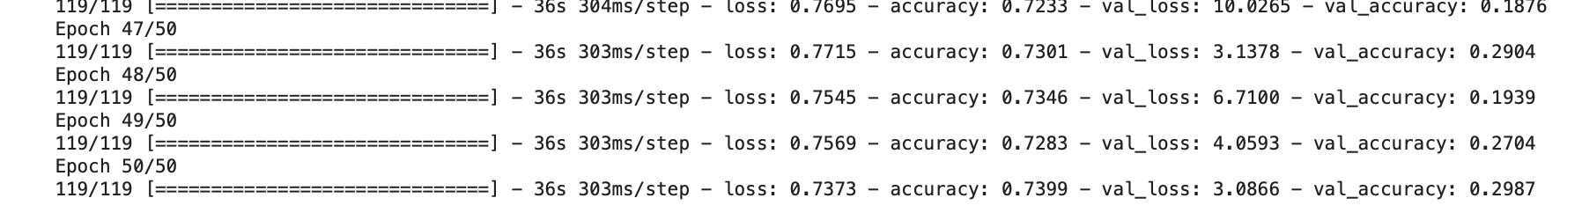

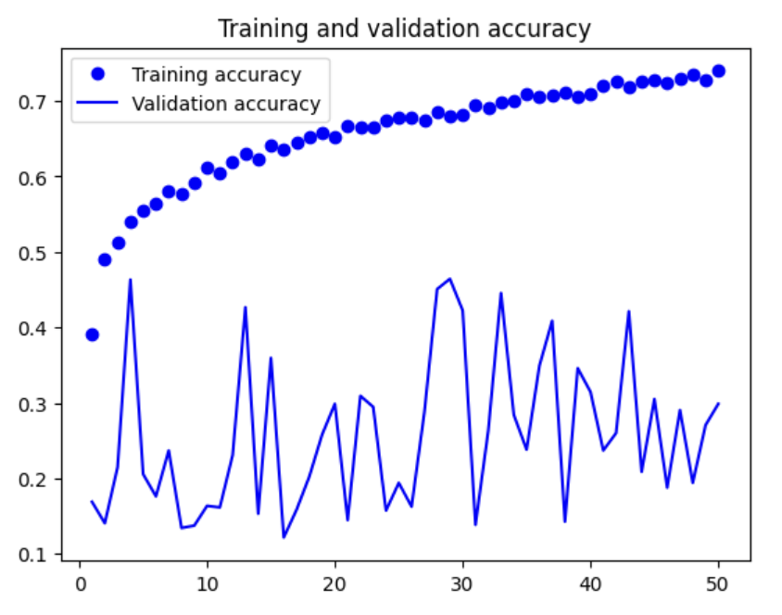 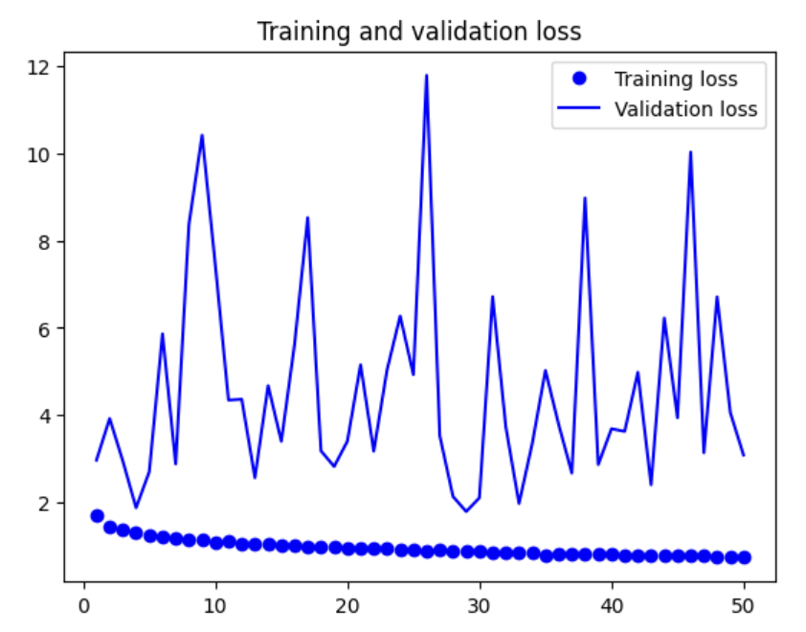

* Building a model from scratch 3, 30 epochs
* # defining the data augmentation stage
* # loading libraries
* from tensorflow import keras
* from keras import layers
* # defining the data augmentation stage
* data_augmentation = keras.Sequential( # defining the data augmentation
* [
* layers.RandomFlip("horizontal"), # adding random horizontal flip (this will flip the image horizontally with a 50% probability)
* layers.RandomRotation(0.1), # adding random rotation (this will rotate the image by a random angle between -0.1 and 0.1 radians)
* layers.RandomZoom(0.2), # adding random zoom (this will zoom the image by a factor between 0.8 and 1.2)
* ]
* )
* from tensorflow import keras
* from tensorflow.keras import layers
* # Input layer
* inputs = keras.Input(shape=(524, 524, 3))
* # Data augmentation layer
* x = data_augmentation(inputs)
* # Rescaling layer
* x = layers.Rescaling(1./255)(x)
* # Simplified convolutional base
* for size in [32, 64, 128, 256]:
* x = layers.Conv2D(size, 3, padding="same", activation="relu")(x)
* x = layers.MaxPooling2D(2)(x)
* # Global average pooling and dense output layer
* x = layers.GlobalAveragePooling2D()(x)
* x = layers.Dropout(0.5)(x)
* outputs = layers.Dense(9, activation="softmax")(x)
* # Create model
* model = keras.Model(inputs=inputs, outputs=outputs)

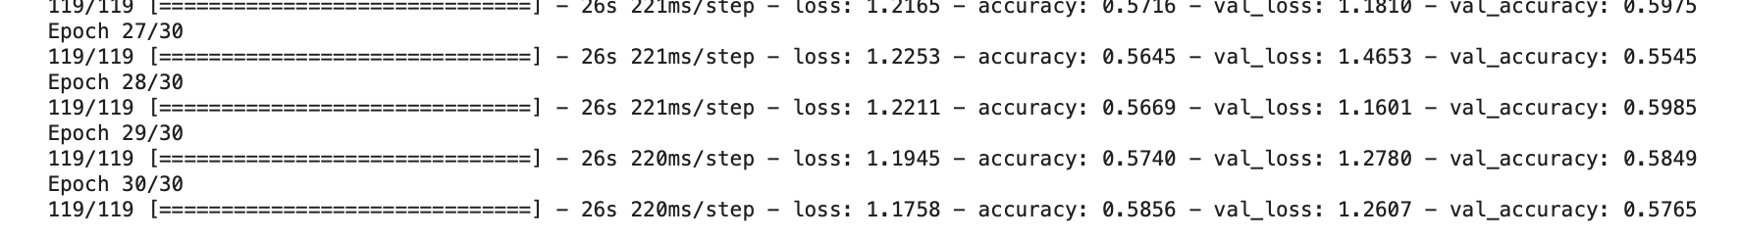

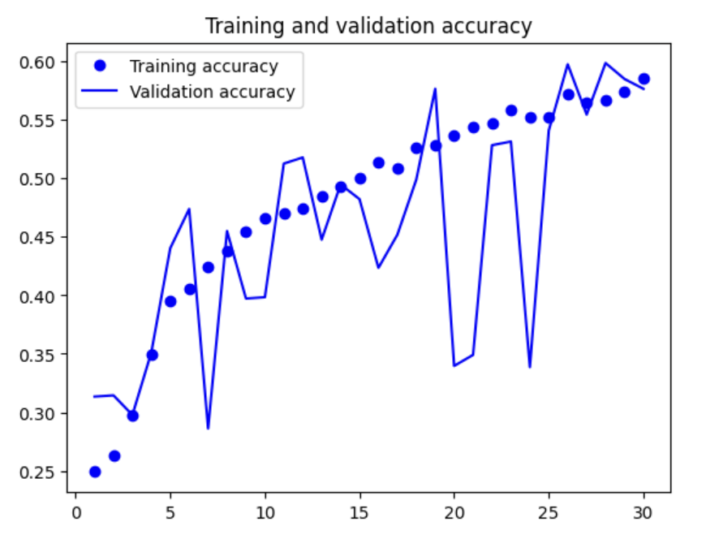 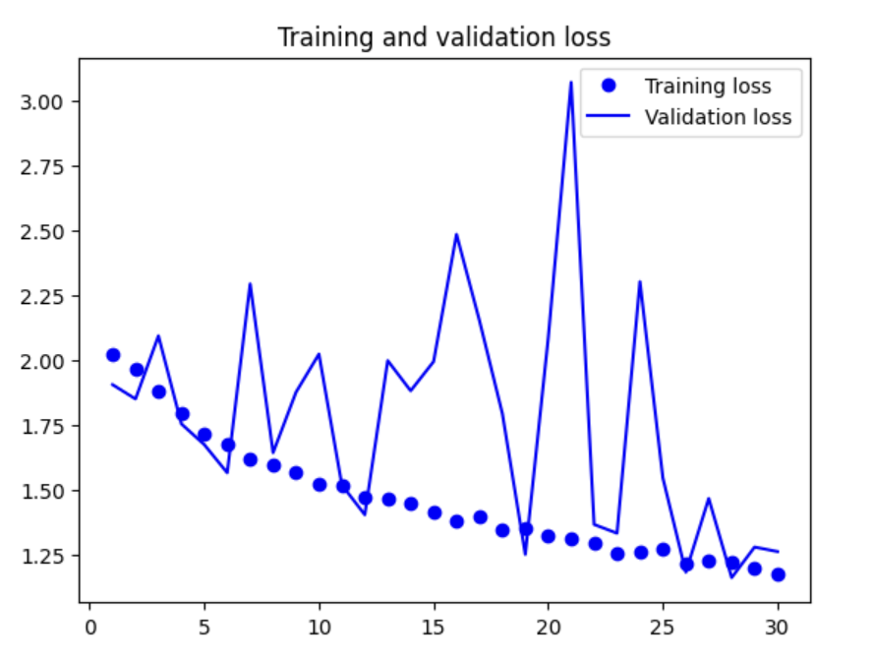

* Building a model from scratch 4, 50 epochs
* # defining the data augmentation stage
* # loading libraries
* from tensorflow import keras
* from tensorflow.keras import layers
* import tensorflow as tf
* # Defining the data augmentation stage
* data_augmentation = keras.Sequential(
* [
* layers.RandomFlip("horizontal"),
* layers.RandomRotation(0.1),
* layers.RandomZoom(0.2),
* layers.RandomContrast(0.1),
* layers.RandomBrightness(0.1)
* ]
* )
* # instantiating the convnet with data augmentation
* # loading libraries
* from tensorflow import keras
* from tensorflow.keras import layers
* # defining the model with data augmentation
* inputs = keras.Input(shape=(524, 524, 3)) # defining defining the input shape based on the image dimensions and the number of channels (3 for RGB)
* x = data_augmentation(inputs) # augmenting the input
* x = layers.Rescaling(1./255)(x) # rescaling the input values to be between 0 and 1 since the pixel values are between 0 and 255
* x = layers.Conv2D(filters=32, kernel_size=3, activation="relu")(x) # defining the convolutional layer
* x = layers.MaxPooling2D(pool_size=2)(x) # defining the max pooling layer
* x = layers.Conv2D(filters=64, kernel_size=3, activation="relu")(x) # defining the convolutional layer based on the previous layer
* x = layers.MaxPooling2D(pool_size=2)(x) # defining the max pooling layer based on the previous layer
* x = layers.Conv2D(filters=128, kernel_size=3, activation="relu")(x) # defining the convolutional layer based on the previous layer
* x = layers.MaxPooling2D(pool_size=2)(x) # defining the max pooling layer based on the previous layer
* x = layers.Conv2D(filters=256, kernel_size=3, activation="relu")(x) # defining the convolutional layer based on the previous layer
* x = layers.MaxPooling2D(pool_size=2)(x) # defining the max pooling layer based on the previous layer
* x = layers.Conv2D(filters=256, kernel_size=3, activation="relu")(x) # defining the convolutional layer based on the previous layer
* x = layers.Flatten()(x) # flattening the output
* x = layers.Dropout(0.5)(x) # adding dropout
* outputs = layers.Dense(9, activation="softmax")(x) # defining the output layer, specifying the number of classes to be 9 (the number of classes in the dataset), and using softmax since it is a multi-class, single-label classification problem
* model = keras.Model(inputs=inputs, outputs=outputs) # creating the model

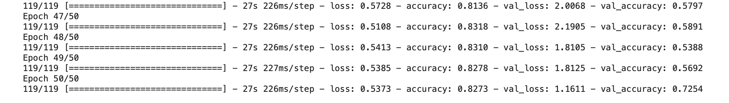

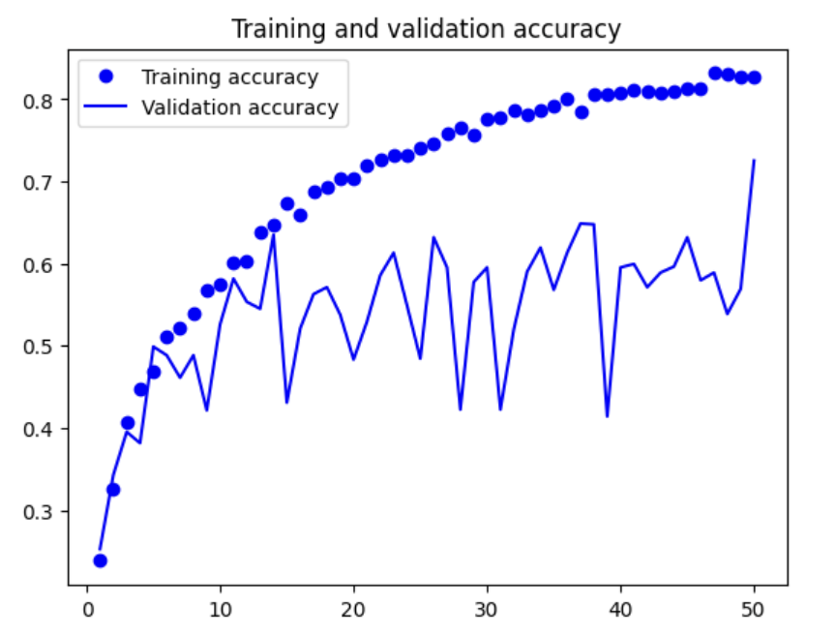 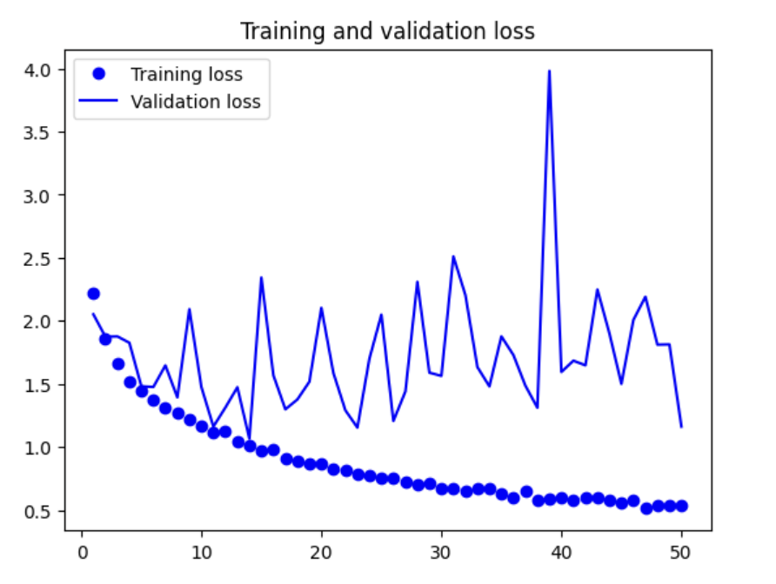

* VGG16
  + Pretrained model with feature extraction
    - 1. Fast feature extraction without data augmentation
      * With shape 224, batch size 4

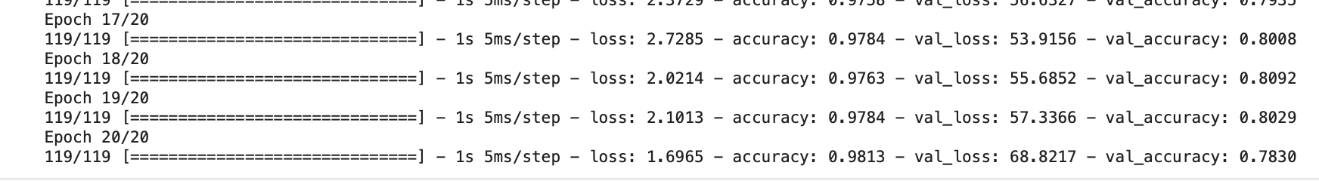

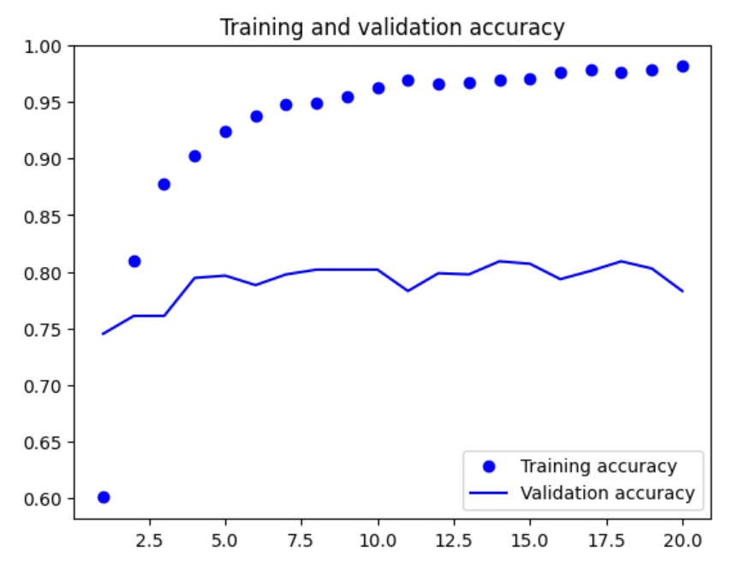 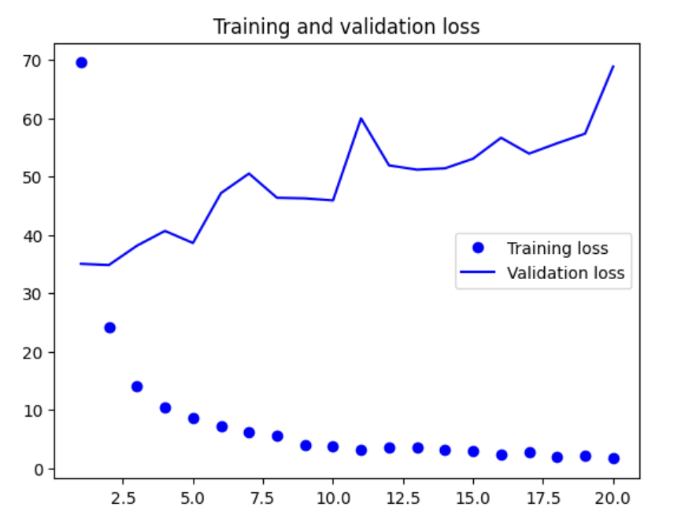

* + - * With shape 224, batch size 32

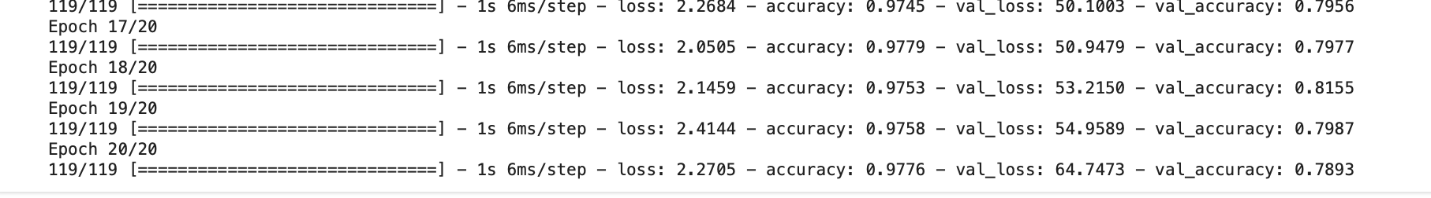

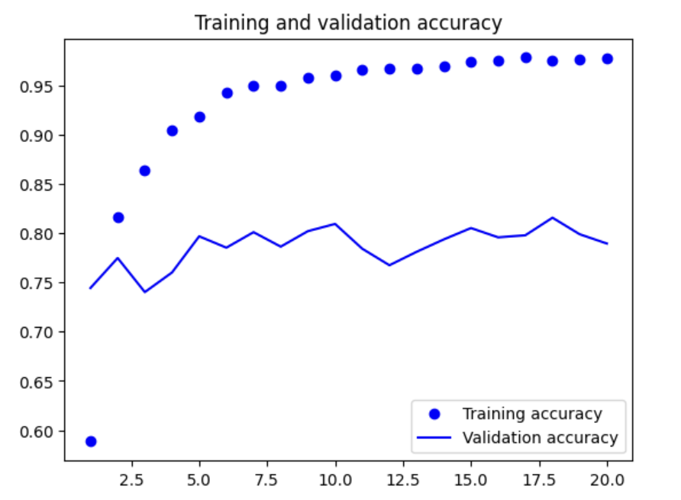 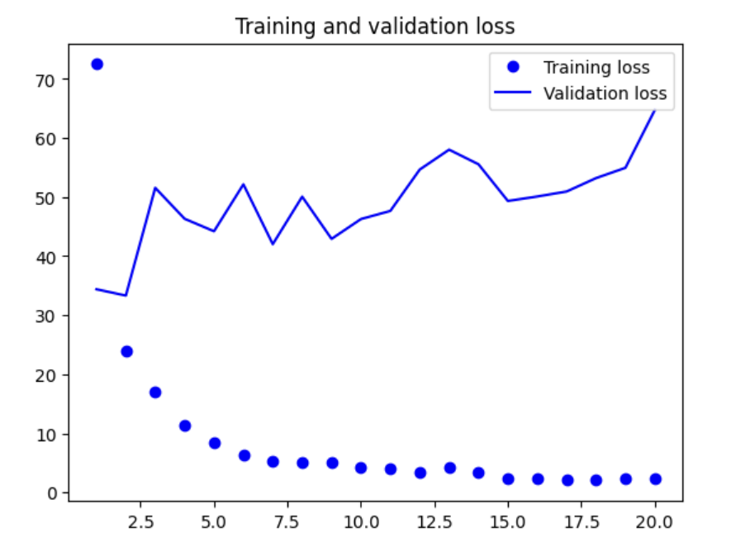

* + - * With shape 524

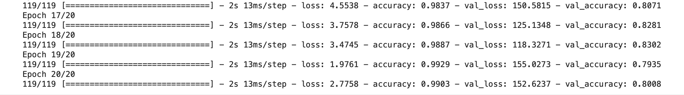

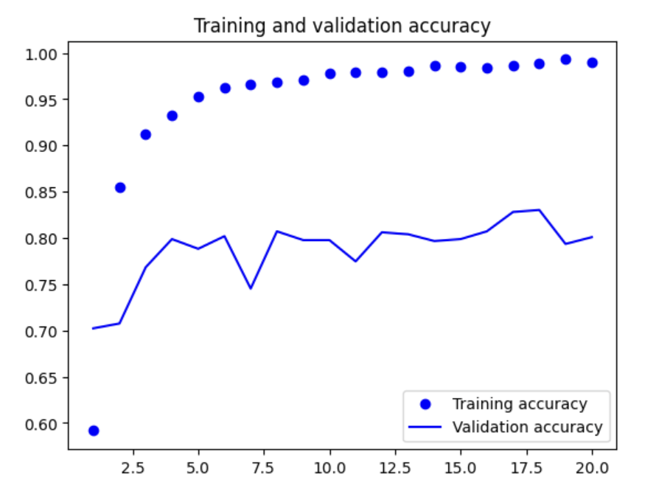 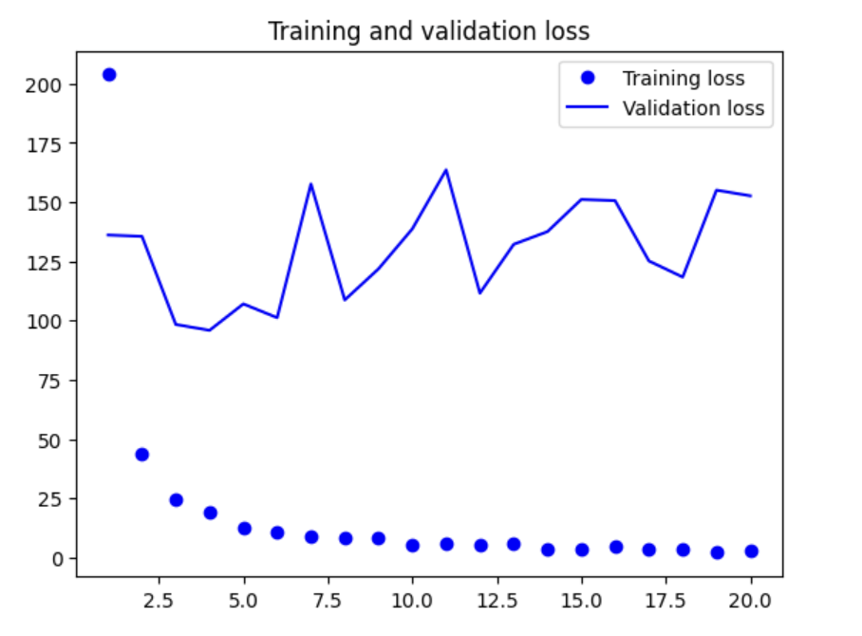

* + - 2. Feature extraction together with data augmentation
      * With shape 224, batch size 4

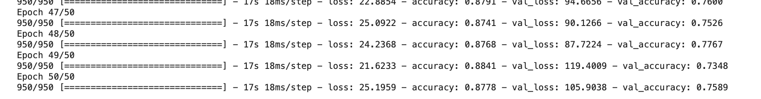

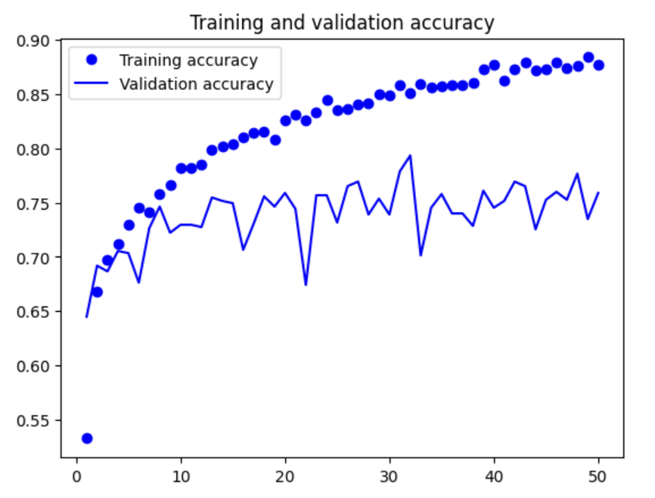 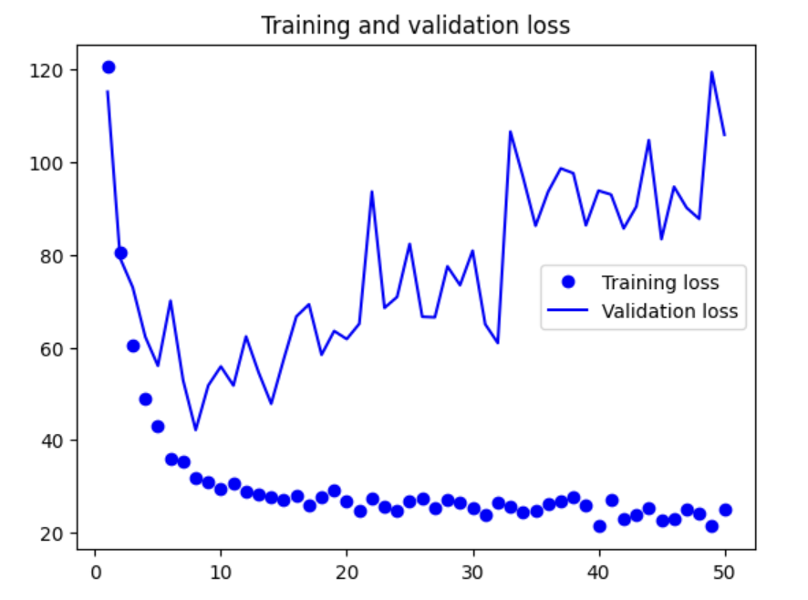

* + - * With shape 224, batch size 32

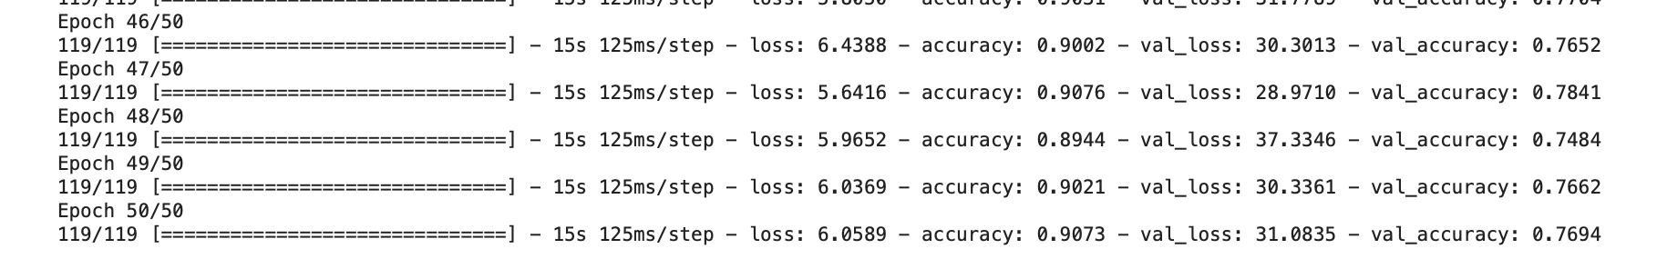

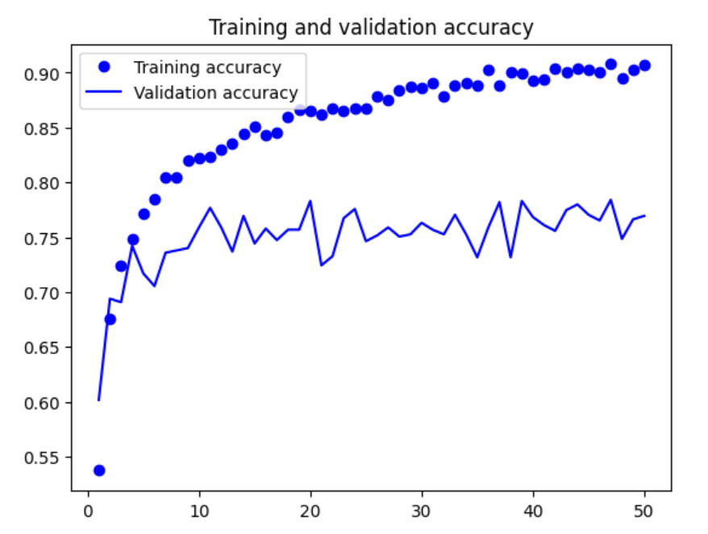 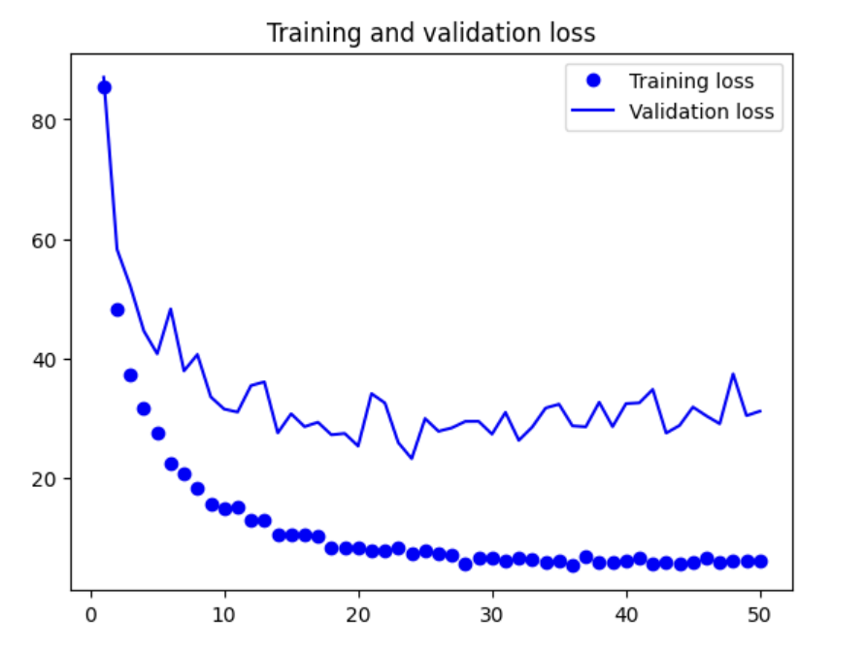

* + - * With shape 524

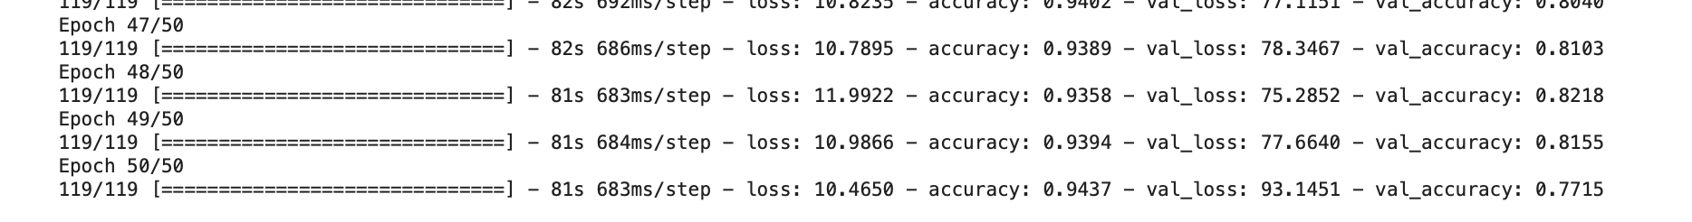

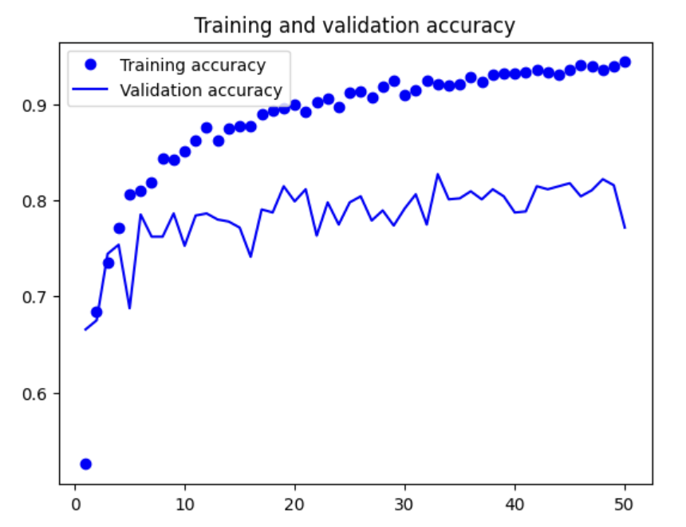 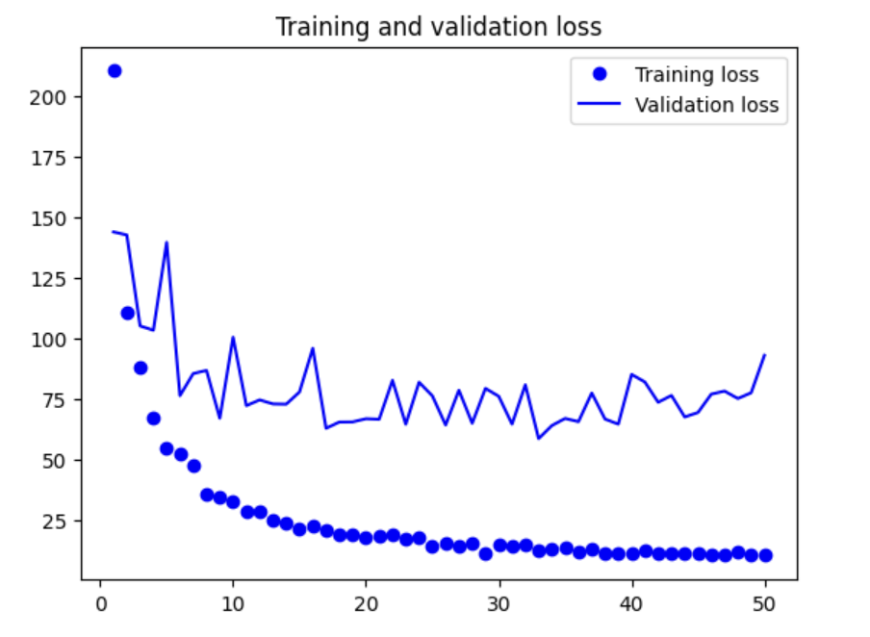

* + Fine-tuning a pretrained model
    - With shape 224, batch size 4

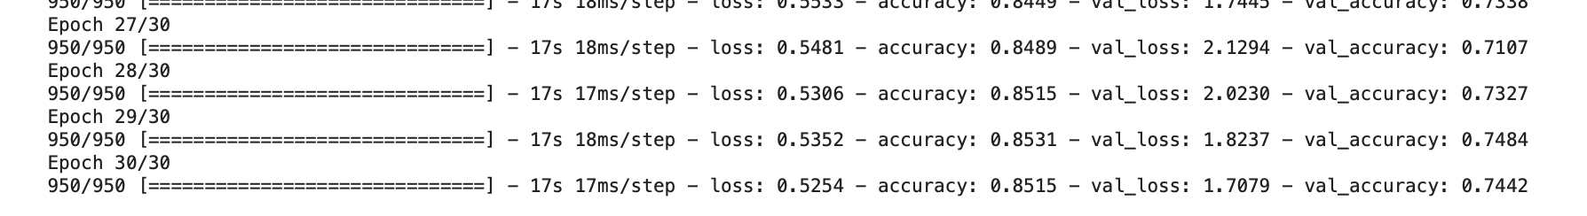

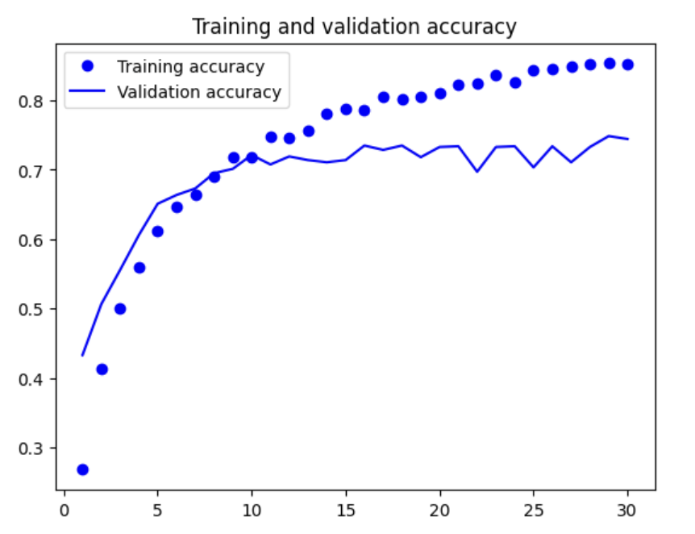 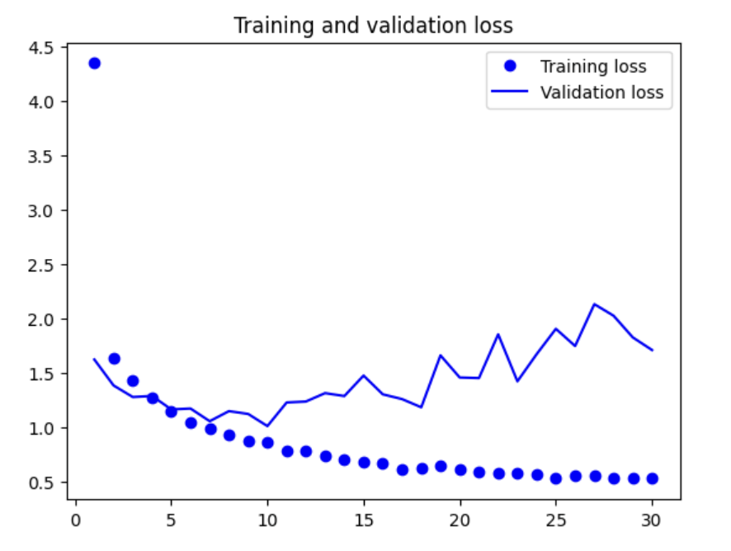

* + - With shape 224, batch size 32

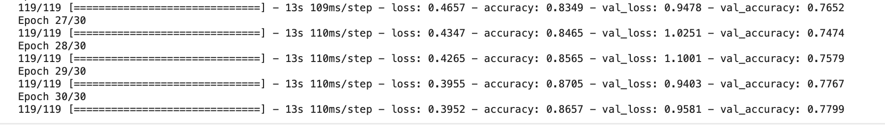

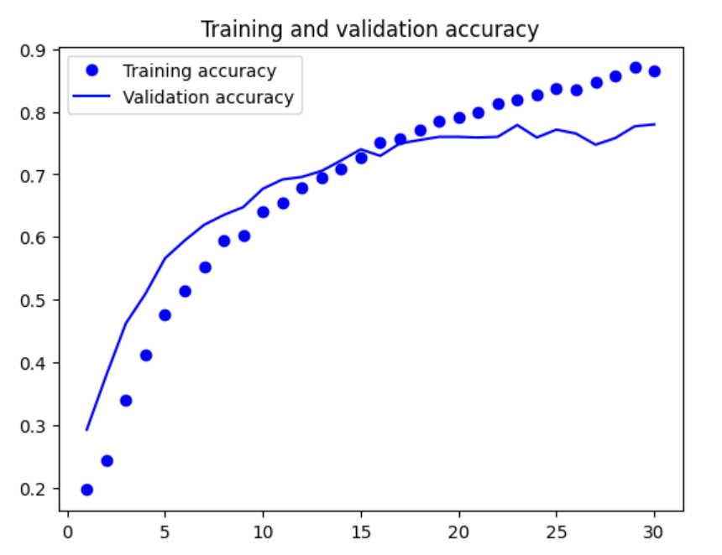 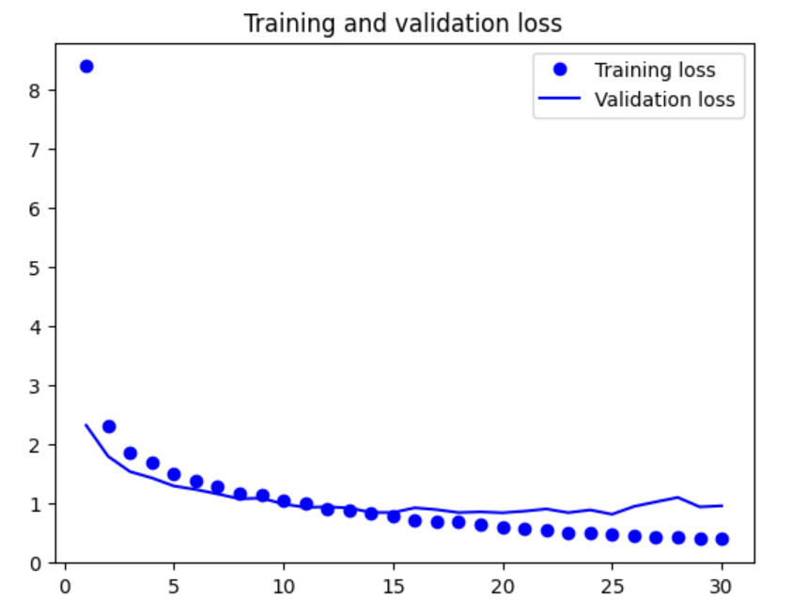

* + - With shape 524

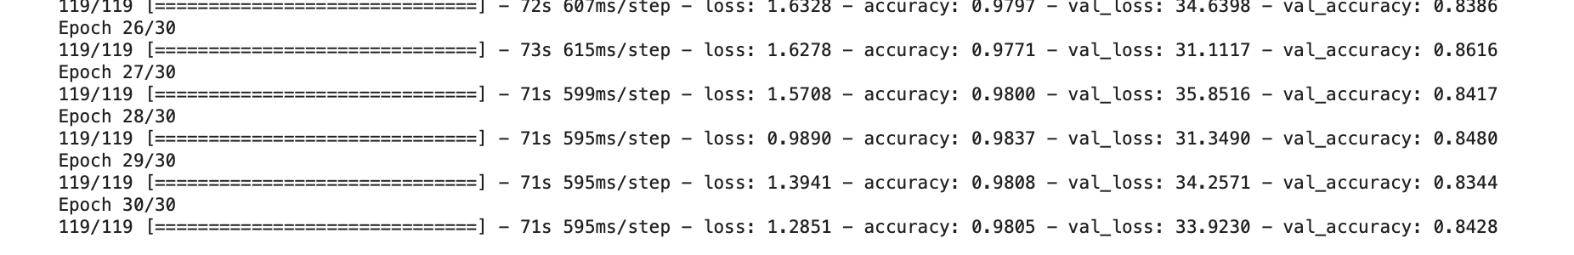

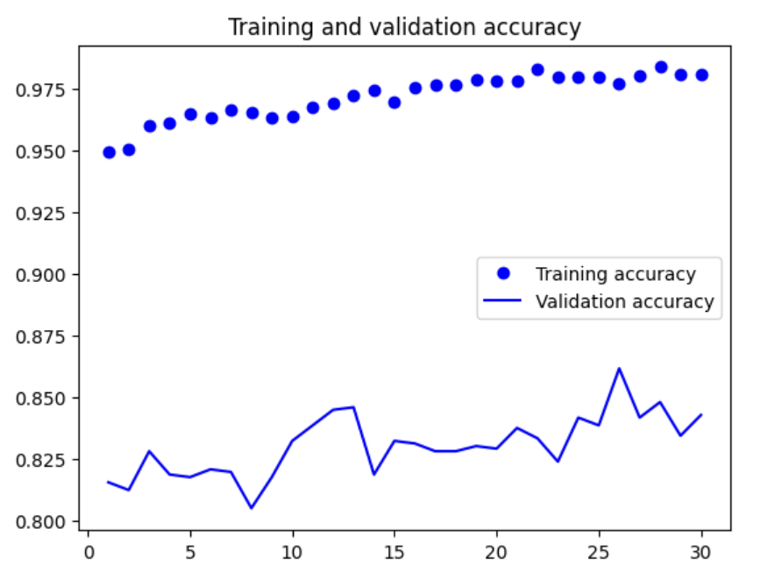 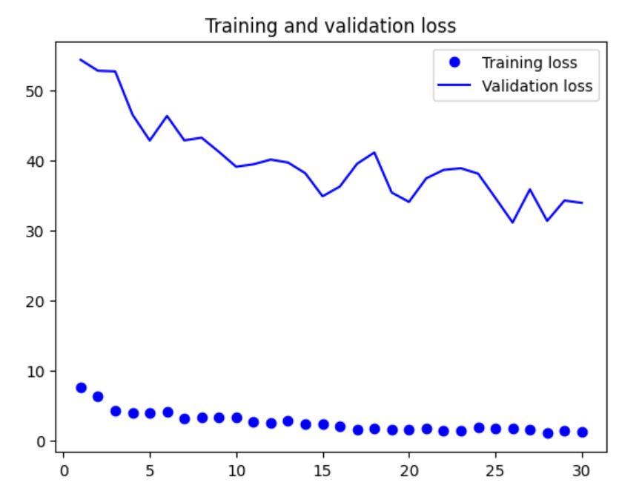

* Inception V3
  + Pretrained model with feature extraction
    - 1. Fast feature extraction without data augmentation
      * With shape 299

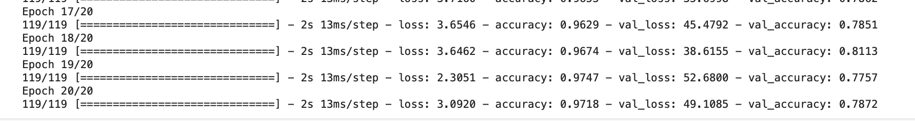

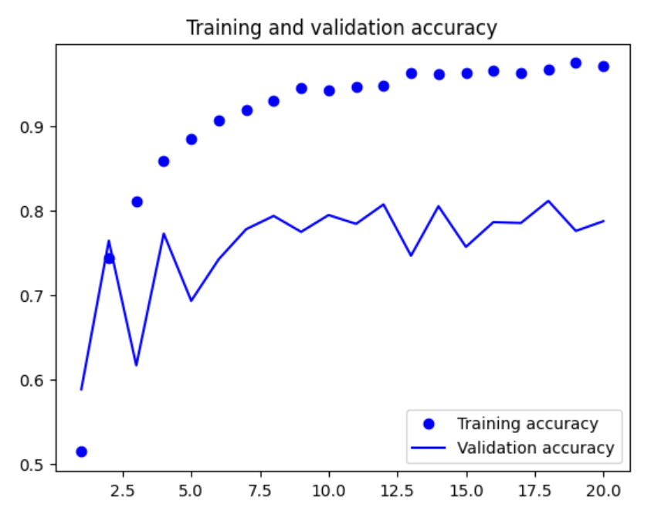 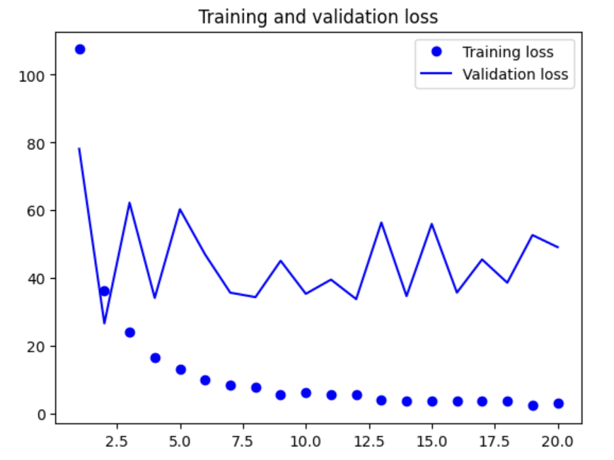

* + - * With shape 524

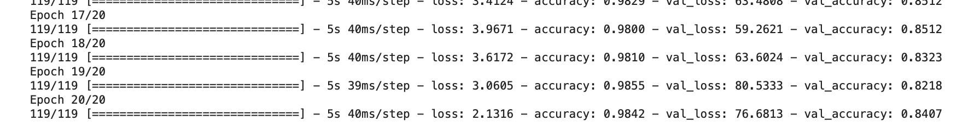

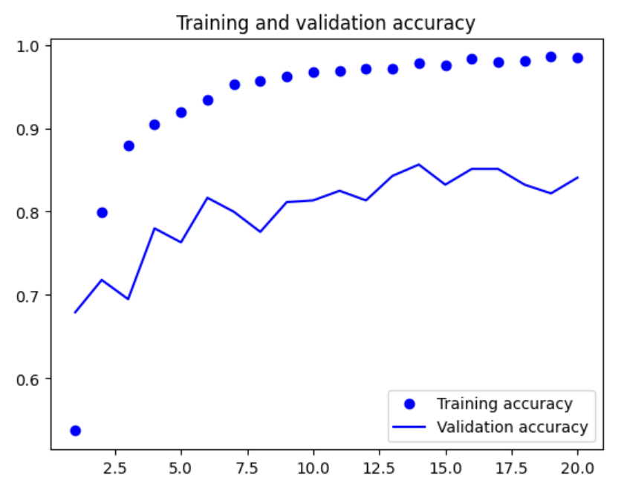 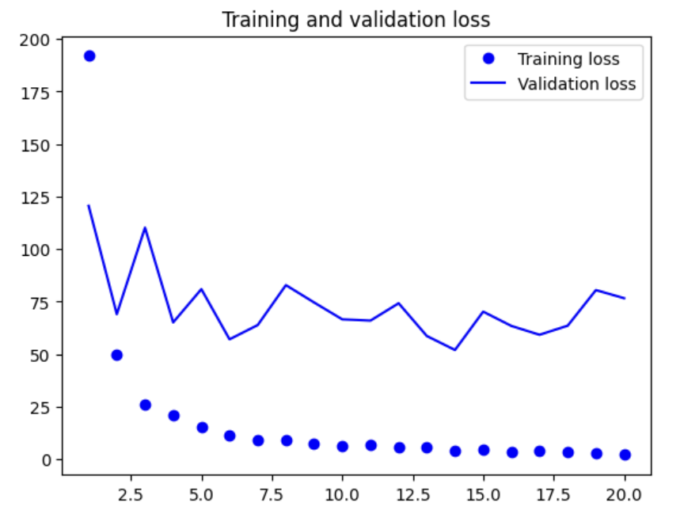

* + - 2. Feature extraction together with data augmentation
      * With shape 299

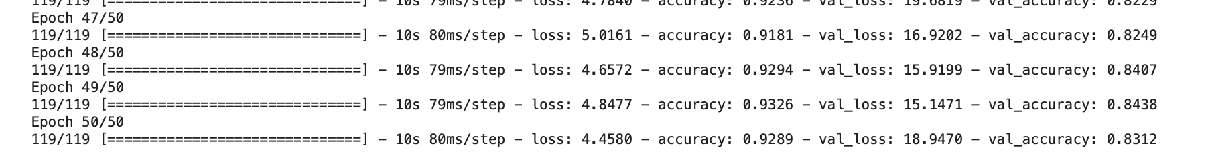

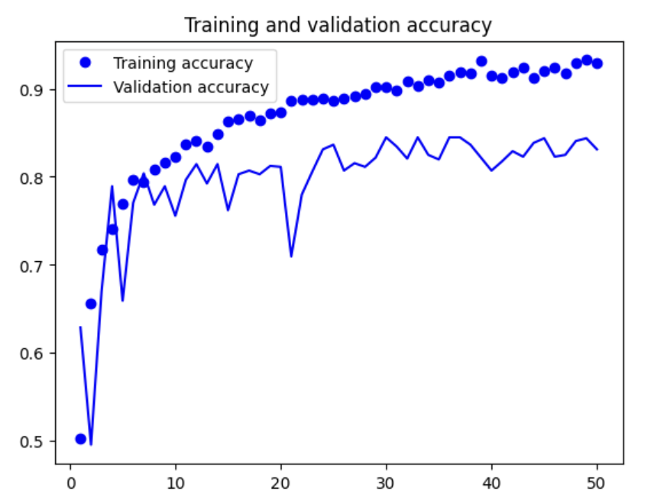 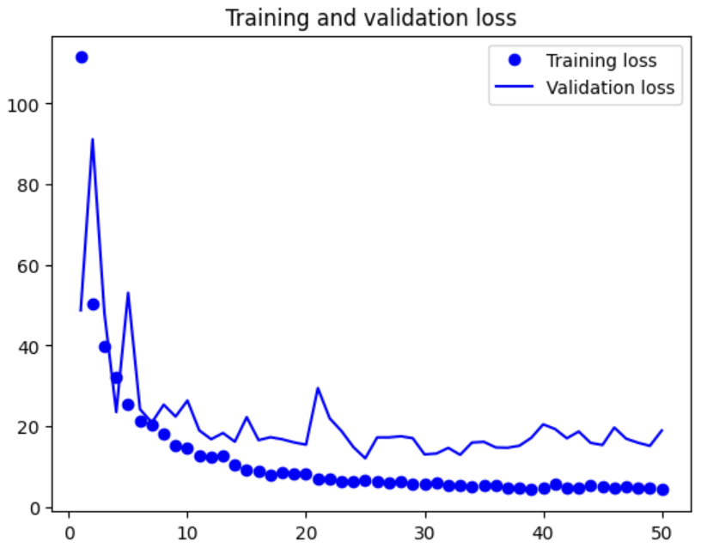

* + - * With shape 524

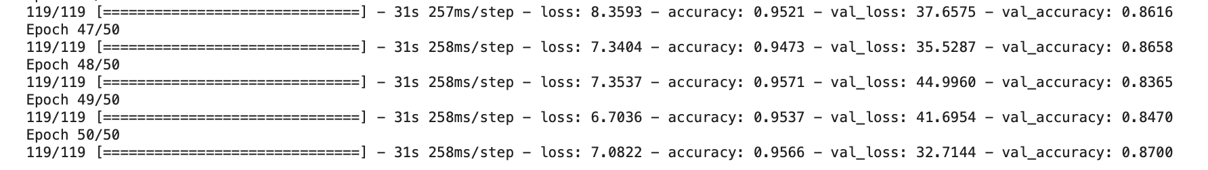

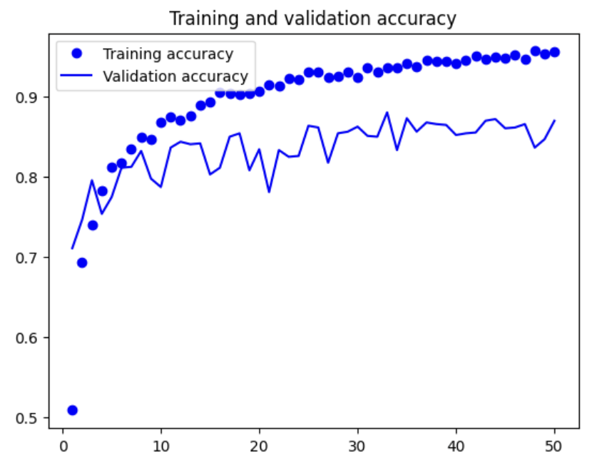 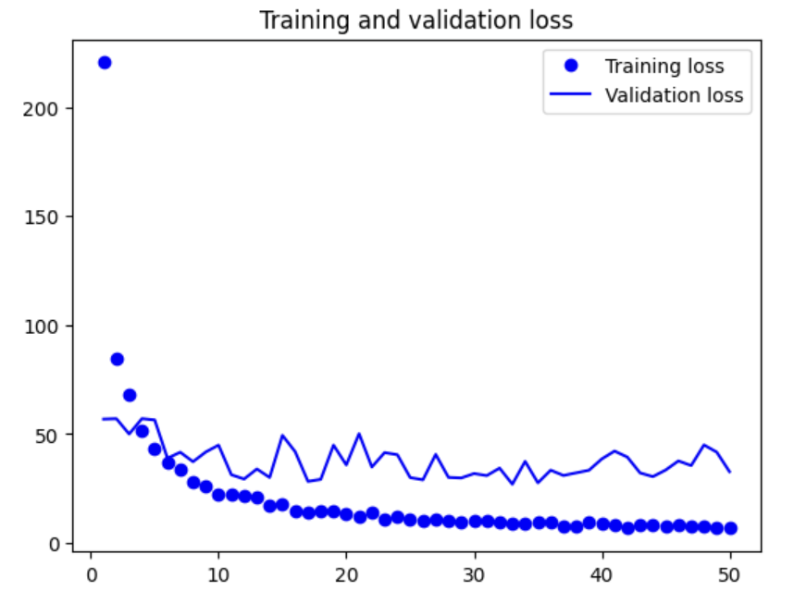

* + Fine-tuning a pretrained model
    - With shape 299

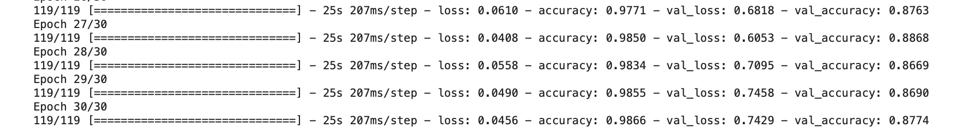

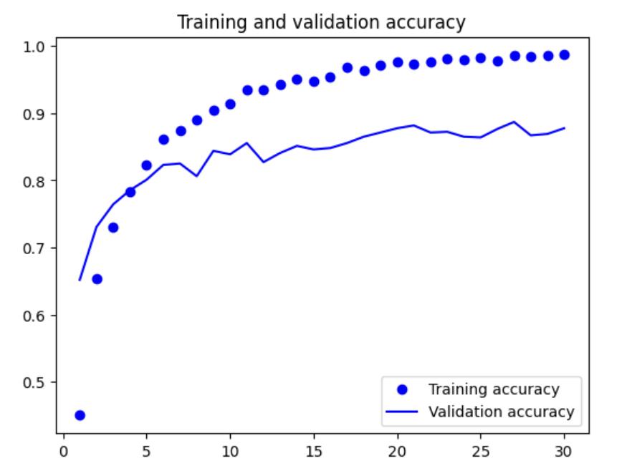 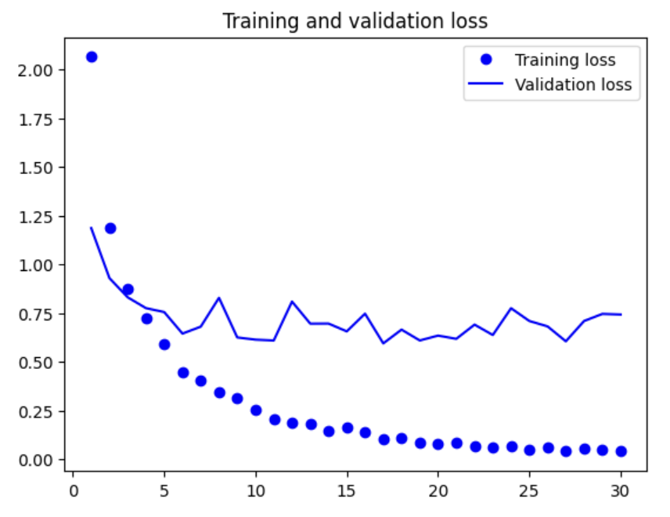

* + - With shape 524

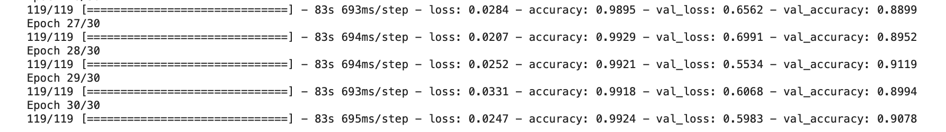

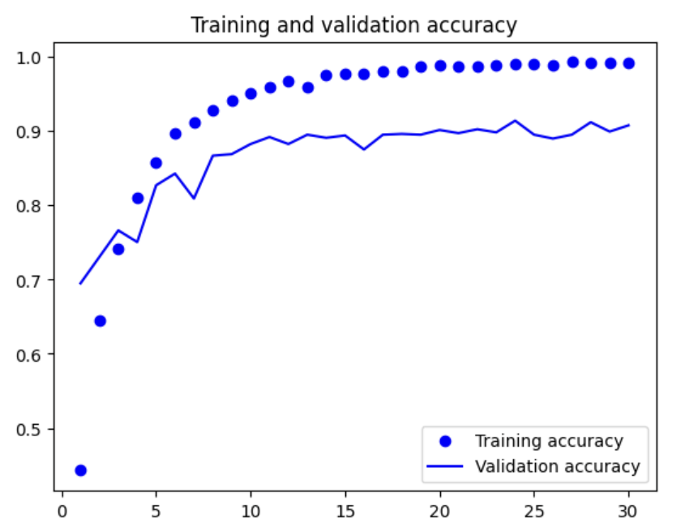 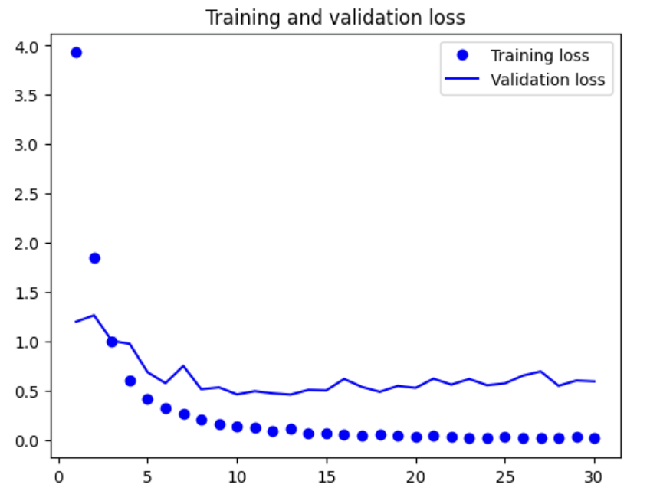

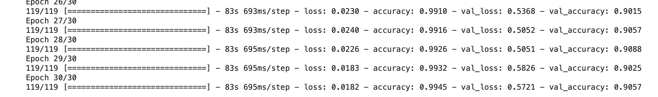

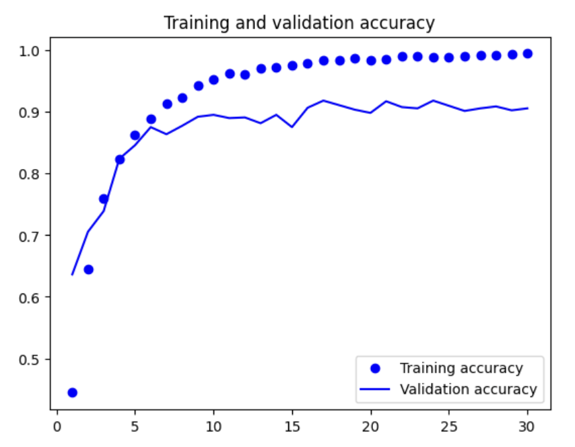 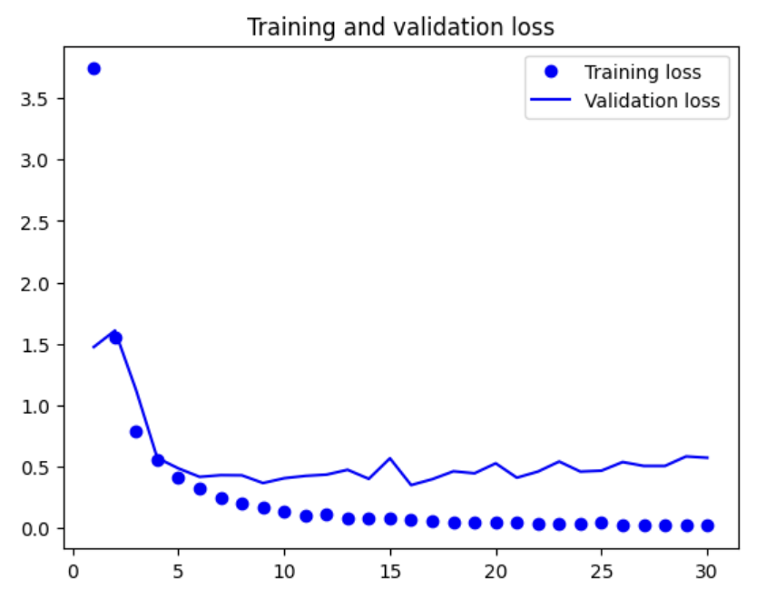

* + - * New freeze

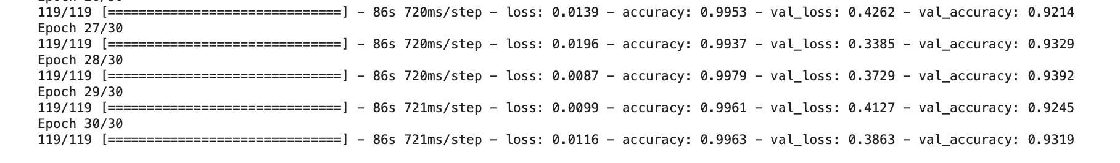

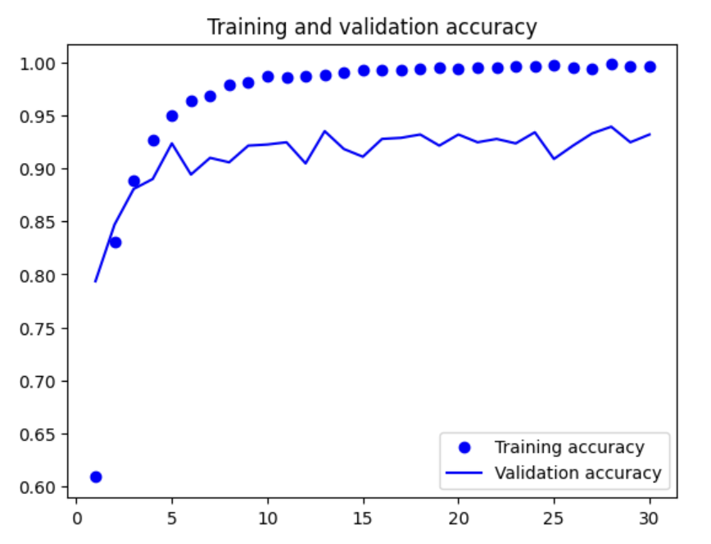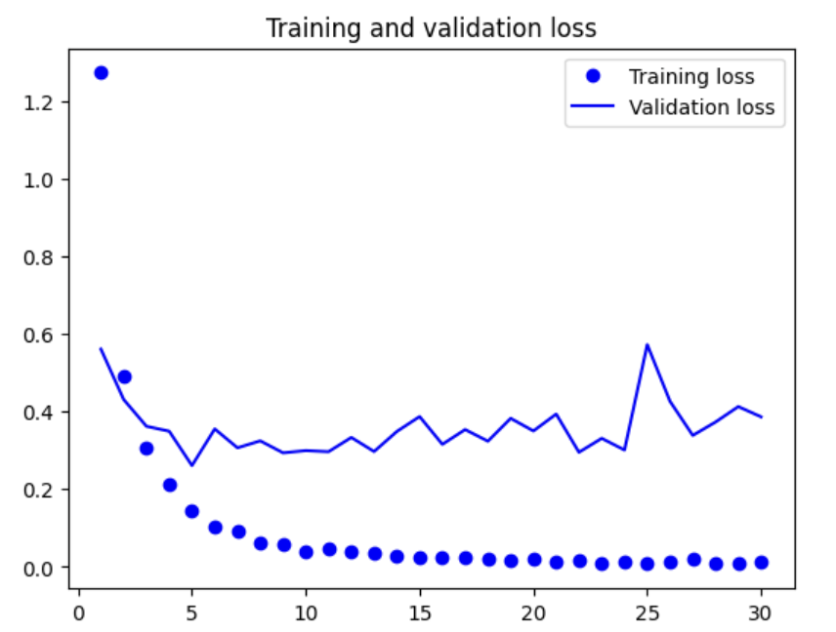

Læs op på modellerne, og hvilken der kunne passe bedst:

* VGG16
  + Running the VGG16 as a good baseline model to compare the other models to, since “VGG16’s combination of simplicity, well-documented performance, and solid baseline accuracy makes it an excellent starting point for many computer vision tasks. It provides a reliable reference to benchmark against, helping to contextualize the improvements and performance of newer, more complex models.”
* DenseNet121
* Inception V3
* InceptionResNet V2
* MobileNetV2